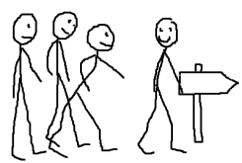
All of us in our group have been to (not school)

.................................................
All of us in our group like...
(could be a TV progamme, a food etc)
.................................................

Only one of us has been to...
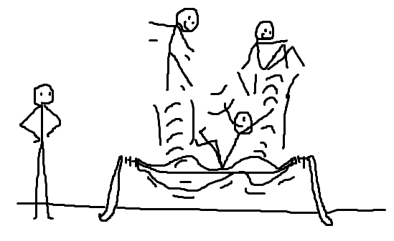
........................................

Only one of us has never...
(could be flown in a plane, taken a dog for a walk, been on a boat...)
.....................................

