Refugees & Asylum Seekers
Refugee Week is taking place 20-26th June 2022. (www.refugeeweek.org.uk).
It’s a festival celebrating the contributions, creativity and resilience of refugees and people seeking sanctuary. This Refugee Week, we’re invited to explore the theme of ‘healing’.

Here we look at opportunities for teaching and learning.

Junior Peacemakers Workshop Guide – A Sense of Belonging: Welcoming refugees & asylum seekers
We put this resource together to enable others to facilitate a workshop either in school or at a different venue. The workshops use circles as the space for learning, inviting child-led discussion, dialogue, participation and play. These peace-themed workshops shine a light on important global themes, whilst making connections to children's everyday lives. They are full day workshops for KS2 pupils.
This workshop supports the aims of Refugee Week and seeks to deepen understanding of why people seek sanctuary. It also supports Cities of Sanctuary. Download the workshop guide here:

https://peacemakers.org.uk/wp-content/uploads/sites/22/2022/03/junior-peacemakers-workshop-guide-March-2022.pdf

Example of one of the activities from the workshop guide - Home
Divide everyone into groups of 4 or 5. If there are a lot of adults, ask them to form a group of their own. Give each group a large piece of paper with the word ‘HOME’ in the middle of it. Ask people to write or draw words, phrases or pictures that come to mind when they think of the word ‘home’. Invite feedback from each group. Everyone’s experience of home will be different and not necessarily positive. Keep the question neutral. Avoid asking, ‘what comes to mind when you think of your home?’

Inclusion and Safety in Circle Time
This is an ideal topic in which to explore ideas of inclusion and safety using circle time activities. By their nature, circles provide the opportunity for all participants to be seen, and to be equal within the space. They also provide the opportunity to encourage everyone to support each other in terms of inclusivity and safety.

Some tips:
- During discussions and games encourage children to make ‘adventurous choices’ about who they choose in the circle. Has everyone had the chance to speak? Are we only choosing our best friends? Is there a tendency for boys to choose boys and girls to choose girls?
- Ask the children for ideas on how games and activities can be adapted to include those who may have English as a second language, who may be shy, or who may have physical disabilities that do not allow them to move easily around the circle.
- If there are children who struggle with the circle as space and not knowing what is going to happen and when, alleviate this by sharing your plan for the session at the beginning.
- Some people worry about allowing children to opt out of a game or an activity in case it sets a precedent. There is no need to present it as an option but in our experience, it can be helpful for less confident children to feel able to opt out. Ask them to remain in the circle so they can still participate as an observer. Usually once these children see that what is going to happen is fun and safe, they either opt to join in anyway, or will opt in next time.

Game: Here I Sit
Play this game with a class who are familiar with circle time and where some of the tips mentioned above, have become established.
- Place an extra chair in the circle. Where there is a spare chair the 2 children either side of it, try to get into this seat.
- Whoever is successful then says ‘Here I sit’. The next person moves into the seat that has just been vacated and says ‘In the forest’.
- The next person then moves into that newly vacated seat and says ‘and I would like to invite…………to come and sit by me’. They can invite anyone in the circle but encourage the adventurous choices.
- The invited person sits next to the person who has made the invitation and that leaves a spare seat at another point in the circle – and the game starts again.

In processing ask the children what it is like to be invited to sit by someone. Did everyone manage to participate in some way? Were people making adventurous choices?

Children’s books on Refugees & Asylum Seekers
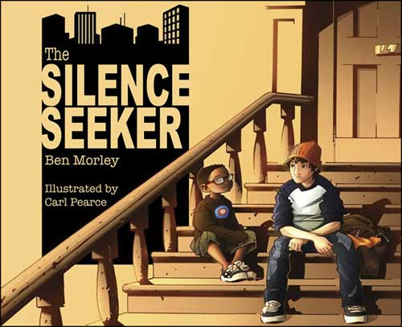

A new family moves in next door to Joe. His mum tells him they are ‘Asylum Seekers’ and they need some peace and quiet. But Joe hears that they are ‘Silence Seekers’ and he sets out to introduce their young son to quiet and peaceful places in the city. Beautiful story by Ben Morley with stunning illustrations from Carl Pearce. Useful links to further support for teachers can be found at: https://globaldimension.org.uk/resource/the-silence-seeker/

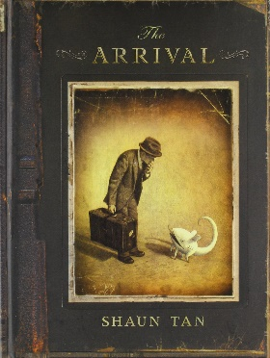
This stunning book, The Arrival by Shaun Tan, tells the story of an immigrant through mysterious pictures and without words. The book is beautifully produced and is something that needs to be touched and felt to be fully appreciated. In the classroom, selected images could be used on a powerpoint, but multiple copies that could be used in small groups is ideal. Some ideas for using it can be found at http://www.teachprimary.com/learning_resources/view/ks2-book-topic-the-arrival The Lost Thing by Shaun Tan is also highly recommended for exploring the theme of identity and belonging.

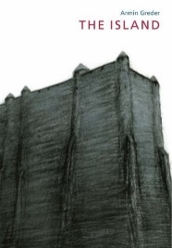
The Island by Armin Greder is a dark story of a stranger who arrives on an island. Although hard-hitting, it lends itself to deeper discussion about anger, fear and hostility. This is an ideal stimulus for Philosophy for Children or for classes familiar with other circle time discussion techniques. The illustrations are stunning and resonate with Munch’s, The Scream.

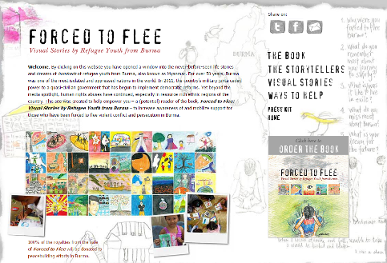
For real life children’s stories and drawings, go to Forced to Flee – Visual Stories by Refugee Youth from Burma. http://burmavisionsforpeace.org/

www.peacemakers.org.uk
@WMQPEP

