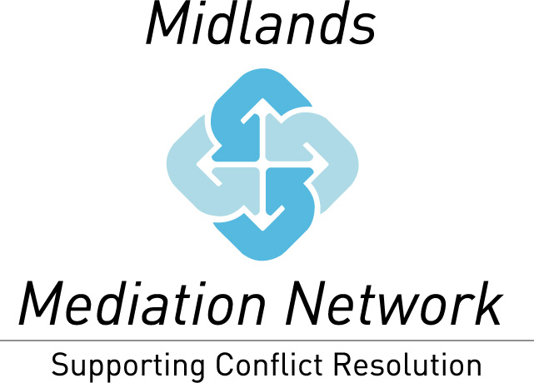

Event Booking Form

Event: |  | Negotiation, Persuasion & High Stakes Decision Making for Mediators & Other Professionals with Prof Liz Stokoe
Time/Date of Event: |  | 5 March 2019, 10am to 3.30pm
Location: |  | West Midlands Fire Service HQ, 99 Vauxhall Road, Birmingham, B7 4HW
Delegate Name |  |  | Email address |  |  | Dietary Needs
Booking made by |  |  |  |  | PO No.
Organisation
Name & Address
Member / Non Member (please indicate which) |  |  |  | Telephone Number
Email Address for Invoice

  - Additional member employees / volunteers £15 per person
  - Non members – early booking discount (where applicable) £35 per person
  - Non members – standard price £50 per person

Payment – invoices will be issued on receipt of your booking. Payment via cheque or BACs is required before the event; unless you are able to supply a PO number for your booking.

Refunds / Cancellation – we require 10 working days notice in order to issue a full refund. Cancellations of 9 working days prior to the event or less will not be refunded.

Please complete and return this form to our Events Co-ordinator, Laura Kirkpatrick:

Email: laura@solutiontalk.co.uk
Post: Solution Talk, 1 Crossfield Avenue, Warrington, WA3 5RS
Phone: 07828 162048

Thank you for your booking. We look forward to seeing you at this event.

